1. 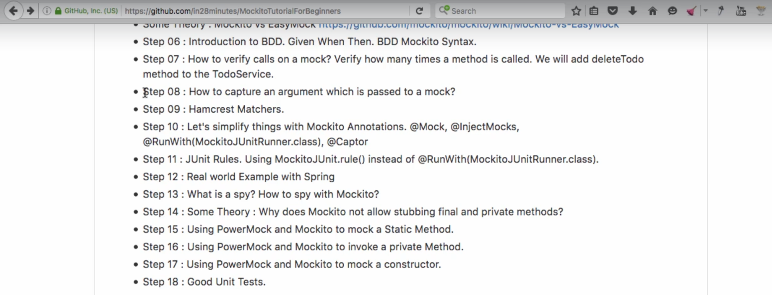
2. We will see how to use Hamcrest matcher.
3. Add the corresponding library.
4. 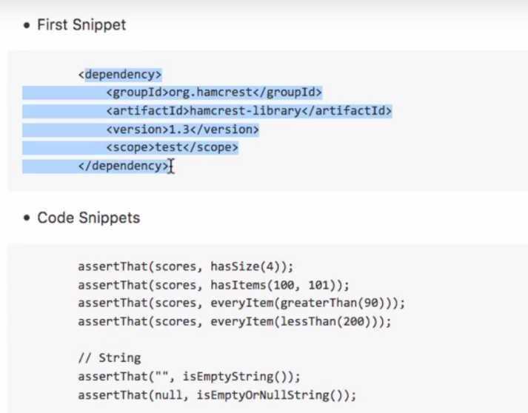
5. See the above code is much easier to understand as compared to usual assert equal syntax.
6. 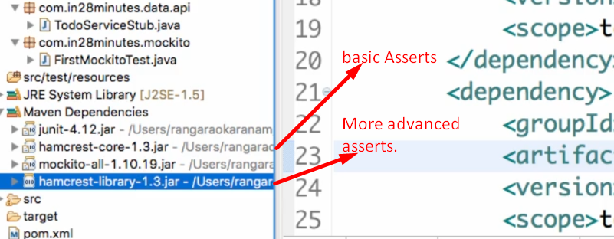
7. 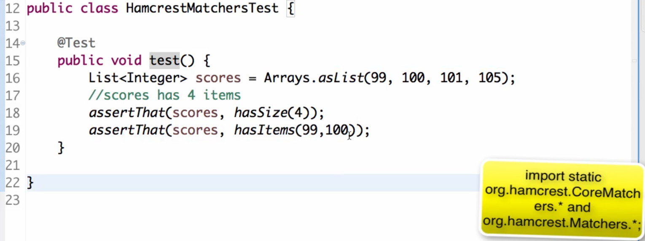
8. 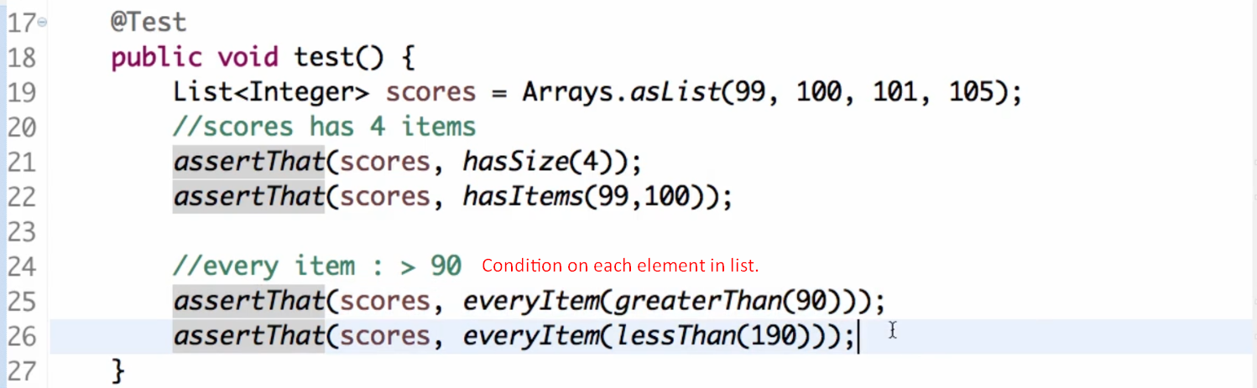
9. 